MADISON Advertising Submission
Standard – 8.25” x 10.75” – Perfect Binding
Email : hello@madisonfashionmagazine.com.au
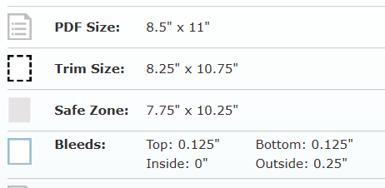
MADISON - Advertising submission guidelines
The Trim can vary slightly, so make sure full page images fill the bleed area and keep text within the safe zone.
Images should be 300 dpi with the original colour profiles embedded in the PDF. Text should be CMYK with the fonts embedded. Don’t use spot colours.

Full Page Advertisement $39.95 AUD
- Includes Full – Page Advertisement in one of our upcoming issues.
- Refer to image for our magazine measurements
- Featured once on our Instagram and Facebook Accounts (story)
- Use high quality graphics and save your advertisement as a PDF in 300 DPI
- We also require a copy of your logo in JPEG and PDF – Include your details - Business Name – Website – Contact Email address
- Set up a discount code to your store using code “MADISON” followed with the amount you wish to give our audience for example, it should look something like this “MADISON15”.

